Regional Communities
Support Pack

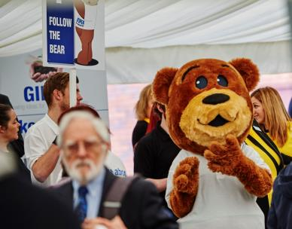
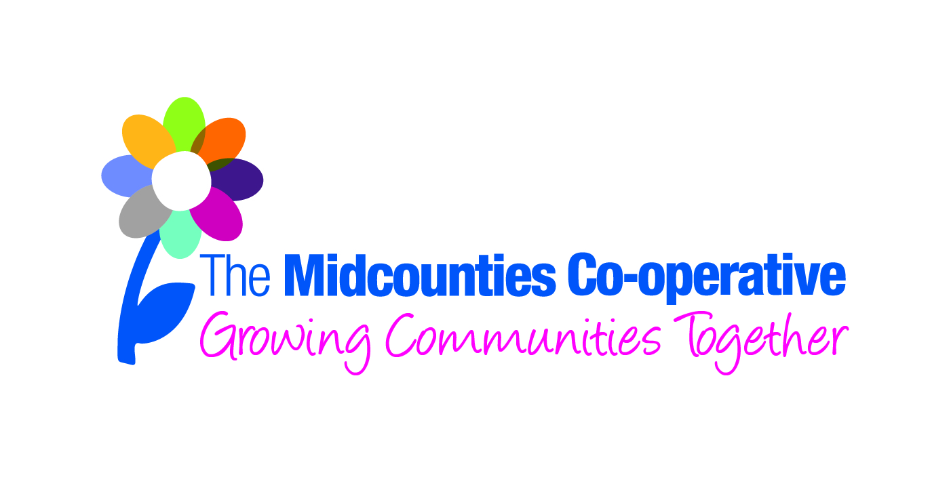

Contents

- Regional Communities Overview

- Regional Community Steering Group & The Role of an Active Member

Regional Community Overview

‘Regional Communities’ is a focussed, measured approach to supporting communities in an identified geographical location where the Society has a strong trading presence.
Measured, with clear KPIs, Regional Communities is a programme that puts Midcounties at the very heart of local life, ensuring that we are truly community owned, community led, and community rewarding.

Context
The Regional Communities approach aims to focus on the real “Co-operative difference”.
To help us to:
- Actively promote our business in the communities we are trading in to enable us to increase the numbers of people who shop with us and drive sales
- Demonstrate the local impact of community spend in our sites
- Encourage member and colleague volunteering opportunities
- Identify the most relevant local opportunities to positively affect the local community, and make a positive difference against the identified local opportunities

The objective is to cement and raise awareness of our position as the leading local business supporter of communities and to “Put members at the heart of everything we do”.

Regional Community areas have been set up in the following areas;
- Kidlington and North West Oxford - Swindon
- Walsall - Cannock and Hednesford
- Wyre Forest - Wolverhampton
- Stroud - Cheltenham
- Chipping Norton - Leamington Spa and Warwick
- Shrewsbury - Sedgley
- Forest Of Dean - White Horse
- Banbury - High Wycombe and Thame
- Bicester - Central Oxford
- Aylesbury
- South Staffordshire

Colleagues and members based within these areas work with the local community to achieve the following KPI’s;
- Increase colleague participation rates in community volunteering
- Ensure that PR is achieved for our community activity
- Increase member involvement
- Carry out fundraising for their local charity partner
- Increase the number of products being donated to their local Foodbank
- Raise awareness in the community of our community grants opportunities
- Increase the number of young people we are engaging with
- Identify the most relevant local opportunities in their ‘Regional Community’ to positively affect the local community, and develop and deliver an action plan to make a positive difference against the identified local opportunities

Each Regional Community area has a Steering Group in place, constitutionally made up from the following as a minimum;
      - 1 Leadership Community Ambassador
      - 1 designated Community Coordinator
      - 1 Active local member
      - 1 democratically elected member (Board member) where applicable
      - Exec member where applicable
      - 1 Executive colleague representative where applicable
      - 1 Site Manager
      - 2 Colleagues

The Steering Groups help develop the strategic direction of their Regional Community, track progress against their targets, and develop activity to help achieve their targets accordingly.

Regional Community Steering Group & the Role of an Active Member

As mentioned previously, each Regional Community area has a Steering Group in place, constitutionally made up from the following as a minimum;
      - 1 Leadership Community Ambassador
      - 1 designated Community Coordinator
      - 1 Active local member
      - 1 democratically elected member (Board member) where applicable
      - Exec member where applicable
      - 1 Site Manager
      - 2 Colleagues

The following describes the role of the Active Member in more detail.

The role of the ‘active’ member – selected from the pool of local active members
- Actively support the rest of the Regional Community Team by attending meetings and conference calls when possible
- Encourage members to attend events/fundraisers/joint volunteering challenges
- Share the good work the group are doing with other local members and community groups as appropriate
- Encourage any community groups you are connected to, to sign up and become members
- Promote the Midcounties Co-operative Community Fund to local community contacts

